- The drop in UK CPI inflation in November largely reflected weaker food and core goods prices, as well as movements in a range of volatile categories. Some of these downward pressures are likely to unwind in the near-term. But we still expect inflation to be on a firm downward trajectory next year, with weaker contributions from the food, energy, and services categories.
- Policy measures announced in last month's Budget and the recent drops in oil and gas futures prices mean we have lowered our 2026 inflation forecast to 2.5%, from 2.8% last month.
CPI inflation slowed to 3.2% in November from 3.6% in October, an outturn that was below our forecast and consensus expectations. November's drop was primarily driven by lower food and core goods prices. The former was partly due to base effects, caused by tobacco duties rising in November last year but December this year. The latter might be influenced by the timing of Black Friday discounting. There were also sizeable downward contributions from the volatile clothing, air fares, and accommodation services categories. RPI and RPIX inflation both fell 0.5ppts in November to 3.8% and 3.7% respectively.
The drag from the volatile categories should unwind in next month's data, and this year's increase in tobacco duties will also appear. But we still expect inflation to be on a downward trajectory through most of 2026. This reflects our view that the contributions of the food and energy categories are set to weaken further next year. Services inflation should also cool, as pay growth eases and the impact of this year's increases in national insurance contributions and the national living wage fade, but progress is likely to be more gradual.
The slowdown in inflation next year is likely to be sharper than we previously forecast, reflecting two factors. First, the government's decision to remove some of the levies from domestic energy bills from April. Second, the fall in wholesale oil and gas futures prices over the past month will exert an additional drag on the contributions of the energy and fuel categories from the spring. As a result, we now expect CPI inflation to average 2.5% in 2026, 0.3ppts lower than last month's forecast.
Chart 1: We've revised down our 2026 forecast due to Budget measures and lower oil and gas prices
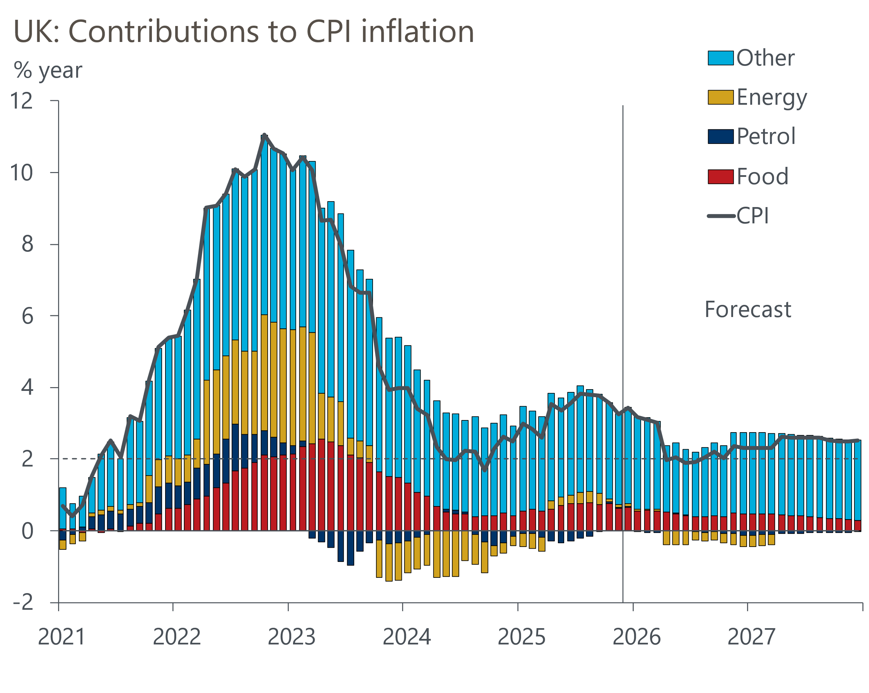
Source: Oxford Economics, Haver Analytics

